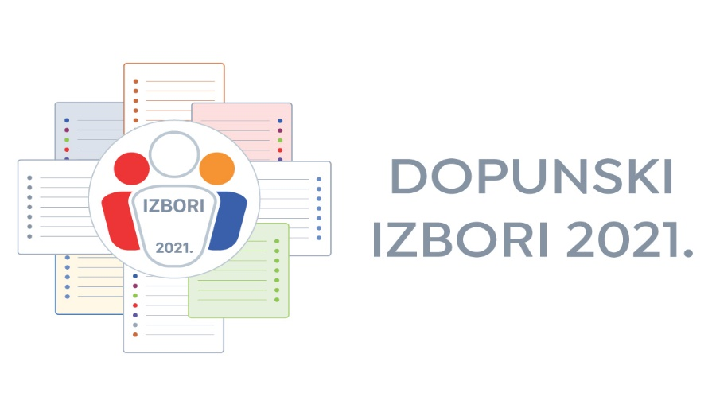

APPLICATION FOR ACCREDITATION AS AN INTERNATIONAL OBSERVER
OF THE 2021 ADDITIONAL LOCAL ELECTIONS

To: Državno izborno povjerenstvo Republike Hrvatske
State Electoral Commission of the Republic od Croatia
Visoka 15, Zagreb, Croatia

dip@izbori.hr

OBSERVER'S INFORMATION

Observer's Name: ________________________________________________________
(Last) (First) (Middle)

Address: _______________________________________________________
(Country) (Postal code) (City) (Street and no.)

Phone: E-mail:
___________________________________________________________________________

PASSPORT INFORMATION

Citizenship _________________________________Passport number_______________

Date of issue _________________________________ Expiry Date _______________

Place of issue _______________________________________________________________

OBSERVER'S SPONSORING AUTHORITY

Name: ______________________________________________________________

Address: ______________________________________________________________

Phone: __________________________________ E-mail: __________________

International Organization Non-Governmental Organization Other (please specify):

Government Regional Organization

___________________________________________________________________________
Signature Date
___________________________________________________________________________Accreditations can be picked up at the State Electoral Commission of the Republic of Croatia, Visoka 15, Zagreb, phone number: + 385 (0)1 2100 600, + 385 (0) 1 2100 601.

